**MANCHESTER PUBLIC LIBRARY MYSTERY BOOK CLUB for 2024-2025**

Use this to remember your impressions of what you read, and to see which of 12 books you liked best.

|  |  |  |  |  |  |  |  |  |  |  |  |  |
| --- | --- | --- | --- | --- | --- | --- | --- | --- | --- | --- | --- | --- |
| *Title And Author*🡺  Adapt to your interests. Ex: I like thrillers – Hence #4 on my list. If you like “Cozies” better, maybe put “0” in #4 but double points for #3A & #3B. | **House at Sea's End** Elly Griffiths | **Devil's Corner**  Lisa Scottoline | **Night Moves**  Jonathan Kellerman | **Thursday Murder Club** Richard Osman | **Poison**  John Lescroart | **The Blood Promise** Mark Pryor | **Law of Innocence** Michael Connelly | **The Lost Man**  Jane Harper | **The Last Alibi**  David Ellis | **The Spy Coast**  Tess Gerritsen | **Death in Brittany**  Jean-Luc Bannalec | **A Calamity of Souls** David Baldacci |
| MONTH 🡺 | SEP | OCT | NOV | DEC | JAN | FEB | MAR | APR | MAY | JUN | JUL | AUG |
| ***POINT OF VIEW***  F- First person; N- Narrator; M- Multiperson (rare) |  |  |  |  |  |  |  |  |  |  |  |  |
| ***SETTING*** C- Contemporary; H- Historical |  |  |  |  |  |  |  |  |  |  |  |  |
| ***SLEUTH*** P- Prof: Cop/Fed/PI/DA; L- Lawyer A- Amateur; V- victim/relative O- Other |  |  |  |  |  |  |  |  |  |  |  |  |
| 1. Got my interest (A) in first few chapters …   (B) kept it through to the end… ***[5 pts each for A & B]*** |  |  |  |  |  |  |  |  |  |  |  |  |
|  |  |  |  |  |  |  |  |  |  |  |  |
| 1. Plot solution?   It was surprising / unexpected |  |  |  |  |  |  |  |  |  |  |  |  |
| 1. Plot solution? (A) the ending was credible.   (B) the loose ends added up. ***[5 pts each for A & B]*** |  |  |  |  |  |  |  |  |  |  |  |  |
|  |  |  |  |  |  |  |  |  |  |  |  |
| 1. Plot overall provided a good degree of suspense / tension. |  |  |  |  |  |  |  |  |  |  |  |  |
| 1. Good use of setting? (It was accurate/ specific enough to be fun; not overdone or distracting.) |  |  |  |  |  |  |  |  |  |  |  |  |
| 1. Dialogue was well done? (It was true to character, convincing, and/or entertaining) |  |  |  |  |  |  |  |  |  |  |  |  |
| 1. Character of sleuth(s) was/were likable, attractive, appealing, interesting, and/or admirable. |  |  |  |  |  |  |  |  |  |  |  |  |
| 1. Other characters seemed real and engaging (not cartoonish / stereotypical / undeveloped) |  |  |  |  |  |  |  |  |  |  |  |  |
| 1. Writing style was mature; it flowed well, while reading. |  |  |  |  |  |  |  |  |  |  |  |  |
| 1. It makes me want to read another book by this author as soon as possible. |  |  |  |  |  |  |  |  |  |  |  |  |
| 1. *OPTIONAL:* Add or deduct up to 10 points for items not covered above. Attach reasons. |  |  |  |  |  |  |  |  |  |  |  |  |
| FINAL SCORE |  |  |  |  |  |  |  |  |  |  |  |  |

Suggestion: use rating 1-10 with 10 being best possible; Note that Items 1 & 3 use 1-5 in both subsections instead. Adjust by Item 11 if desired. Final score is “out of 100.” 95= Solid A, 85=B, 75=C, 65=D, and 55 and below=F. For purposes of group averages, please note:

(1) ***do not give a “fail” lower than a “50,”*** (2) ***your “grade” will count toward the average only if you have read the entire book.***

**GUIDELINES FOR EVALUATING BOOKS**

These guidelines have evolved with the use of the form over the last 10+ years in the MBC. ***In no way is use of the form required!*** All of us have skipped the use of the form to one degree or another. However, since it is our practice to ask participants to give a "score" or "grade" to the books, you have a choice of "winging it" (keeping the teacher grading scale in mind) or filling out the form.

* Final total score is “out of 100.” So that we are all on the same page about this, note:

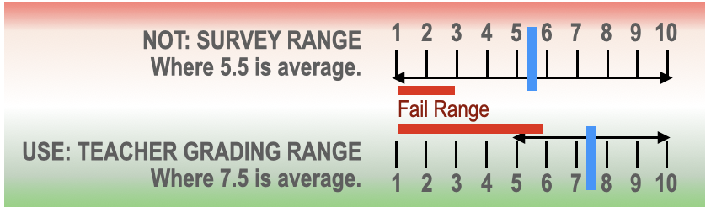

* This is **NOT** like a survey rating of 1 - 10, where 5 is average, 10 is fantastic, and 1 is the worst.
* **This is more like a school grading system** where 7.5 points (or solid C) is average and 5.5 and 5 points (or F) are failing.
* So, most items have a total value of 10 points. Grade like a school grade; let this be your guide:

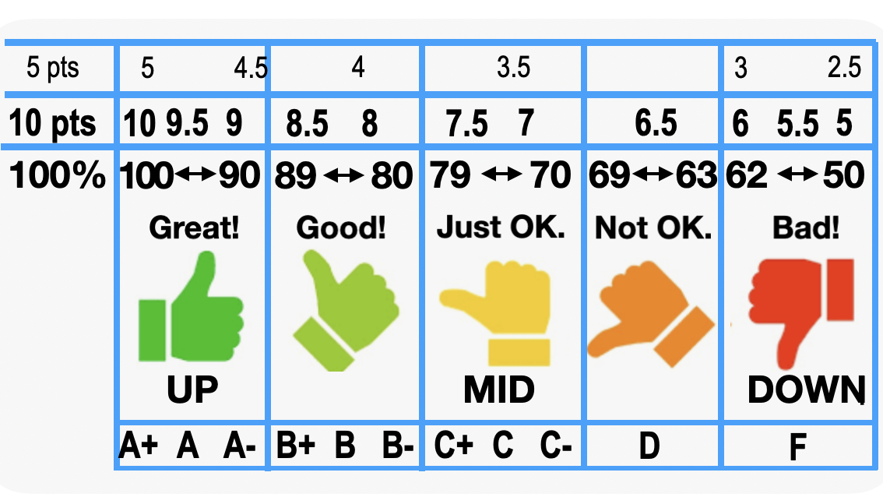

|  |  |
| --- | --- |
| * 10= great! A+ * 9.5 solid A * 8.5= solid B | * 7.5= solid C * 6.5= really poor D * 6 and below is a fail |

* EXCEPTIONS: Items #1 & #3 are divided into two parts, with *each part* a value of just 5, so:

|  |  |
| --- | --- |
| * 5= A or A+ * 4.5 = A- * 4= B- | * 3.5= C- * 3= really poor D- * 2.5 and below is a fail |

* If you feel the 10 questions omitted something that is important to you, that you wish to include in your score, you can manually adjust your score by using optional Item #11. I rarely use this box. When I do, it will be in the range of adding or deducting 1 to 4 points. (That is, for example, a 3 or a –2.) Otherwise, put a zero in the box for Item #11 so that it will not impact the total.
* When you report your score for the group, so that we can compute an average score for the book, ***do not give a “fail” lower than a “50.”*** Anything lower would unfairly impact the overall group average. "50" is the worst score to give. If your total comes lower, adjust it to 50.

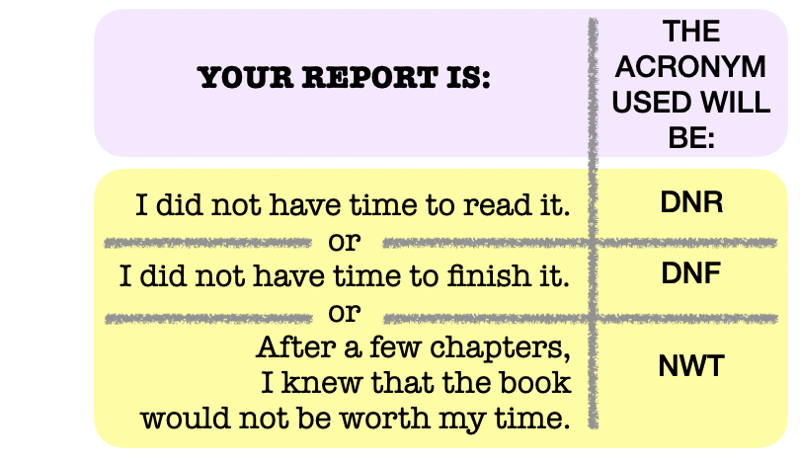

***Your “grade” will count toward the group average only if you have read "essentially" the entire book.*** Most of us have occasions when we run out of time.... or knew after 50 pages we didn't want to read further. After the meeting, when everyone’s book score is shared for the benefit of those who could not attend, the symbols at right will be used –